VNR VJIET
Name of the Experiment: _____________
Name of the Laboratory:
Experiment No: ____ Date: _________
Machine Learning Laboratory

WEEK 5- To implement simple and multiple linear regression models
using Python and analyze their performance on training data from a CSV
file.

23071A1292
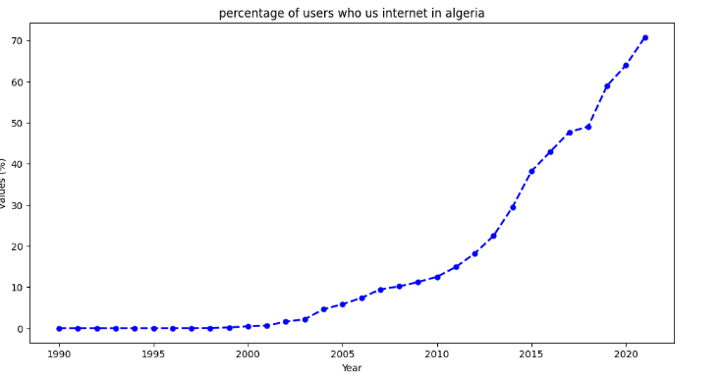
LINEAR REGRESSION

import numpy as np
import pandas as pfd
import matplotlib.pyplot as plt
from sklearn import linear_model
from sklearn.model_selection import train_test_split
from pandas.core.common import random_state
from sklearn.linear_model import LinearRegression
import scipy.stats as stats

import kagglehub
path = kagglehub.dataset_download("fundal/algeria-five-indicators")
print("Path to dataset files:", path)

import os
import pandas as pd
print(os.listdir(path))
dataset_file = os.path.join(path, 'Four_Indicators.csv')
df = pd.read_csv(dataset_file)
display(df.head())

df.describe()
df

plt.figure(figsize=(12,6))
plt.title("percentage of users who us internet in algeria")
plt.xlabel('Year')
plt.ylabel('values (%)')
df.Users_Percentage.plot(kind='line',color='blue',marker='o',linestyle='dashed',linewidth=2,
markersize=5)

23071A1292
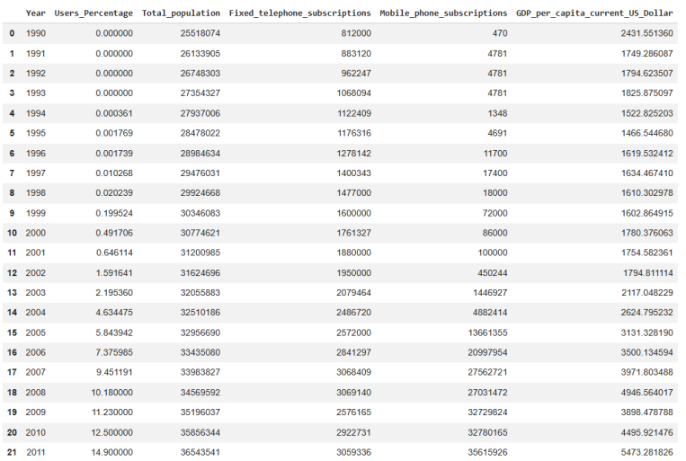
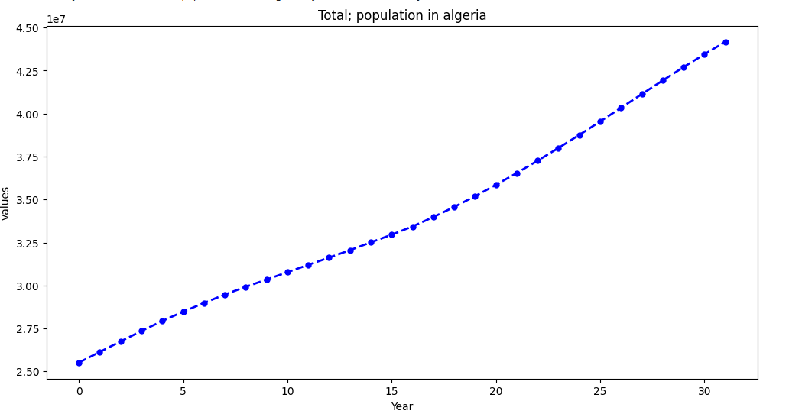
VNR VJIET
Name of the Experiment: _____________
Name of the Laboratory:
Experiment No: ____ Date: _________
Machine Learning Laboratory

indic_df=pd.read_csv(os.path.join(path,'Four_Indicators.csv'))
indic_df

from IPython.core.interactiveshell import dis
indic_df.dropna(how='all', axis=1,inplace=True)
display(indic_df)

plt.figure(figsize=(12,6))
plt.title("Total; population in algeria")
plt.xlabel('Year')
plt.ylabel('values')
indic_df.Total_population.plot(kind='line',color='blue',marker='o',linestyle='dashed',linewidth=2, markersize=5)

23071A1292
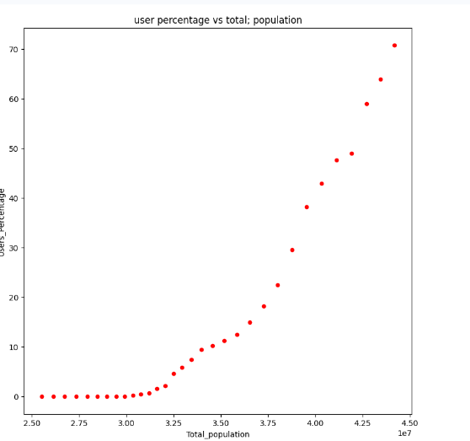

indic_df.plot(kind='scatter',x='Total_population',y='Users_Percentage',figsize=(9,9),color='red')
plt.title("user percentage vs total; population")
plt.show()

regression_model=linear_model.LinearRegression()
regression_model.fit(indic_df[['Total_population']],y=indic_df["Users_Percentage"])
print("y-intercept")
print(regression_model.intercept_)
print("------------")
print("model coefficient")
print(regression_model.coef_)
print("--------")
print("score")
regression_model.score(indic_df[['Total_population']],indic_df["Users_Percentage"])
train_prediction=repr(regression_model.predict(indic_df[['Total_population']]))
print(train_prediction)
residuals=indic_df["Users_Percentage"]-regression_model.predict(indic_df[['Total_population']])
indic_df.plot(kind='scatter',x='Total_population',y='Users_Percentage',figsize=(9,9),color='red')
plt.plot(indic_df[['Total_population']],regression_model.predict(indic_df[['Total_population']]),color='bl
ue',linewidth=3)

23071A1292
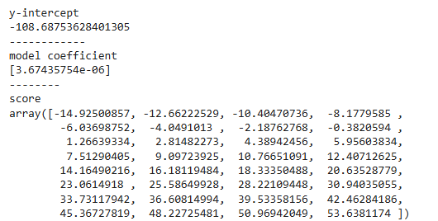
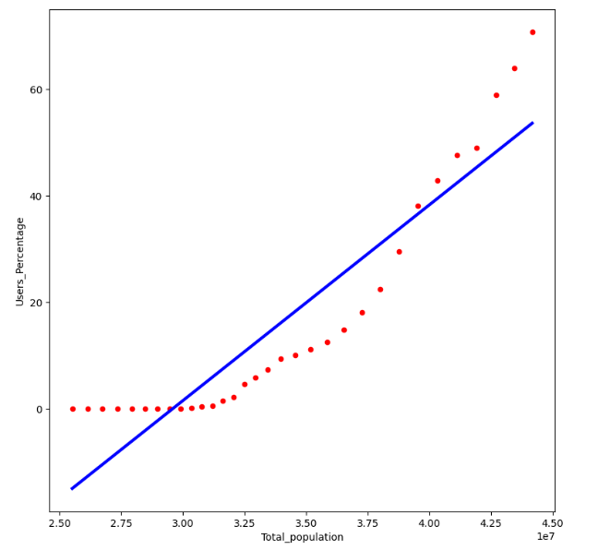
VNR VJIET
Name of the Experiment: _____________
Name of the Laboratory:
Experiment No: ____ Date: _________
Machine Learning Laboratory

Conclusion:
The graph shows that urban population increases as total population increases, indicating a positive
relationship between the two. However, the data follows a curved pattern while the fitted line is linear,
so the model does not represent the trend accurately. This suggests that a non-linear model would
better capture the relationship than a simple linear regression.

23071A1292
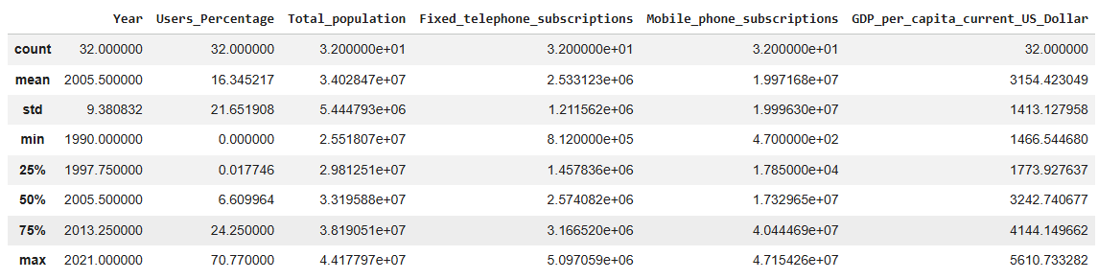
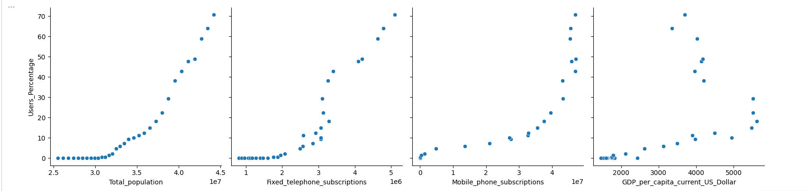
MULTIPLE REGRERSSION

from sklearn import metrics
from sklearn.metrics import mean_squared_error,mean_absolute_error
from sklearn.model_selection import train_test_split, cross_val_score

indic_df.describe()

x=indic_df[["Total_population","Fixed_telephone_subscriptions","Mobile_phone_subscriptions","GDP_per_capita_curr
ent_US_Dollar"]]
y=indic_df['Users_Percentage']

import seaborn as sns
sns.pairplot(indic_df,
x_vars=["Total_population","Fixed_telephone_subscriptions","Mobile_phone_subscriptions","GDP_per_capita_current
_US_Dollar"], y_vars="Users_Percentage", height=4, aspect=1, kind='scatter')
plt.show()

23071A1292
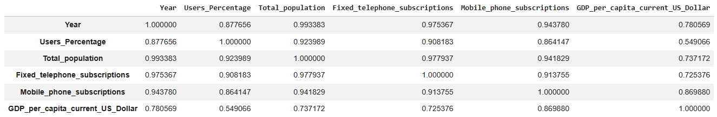
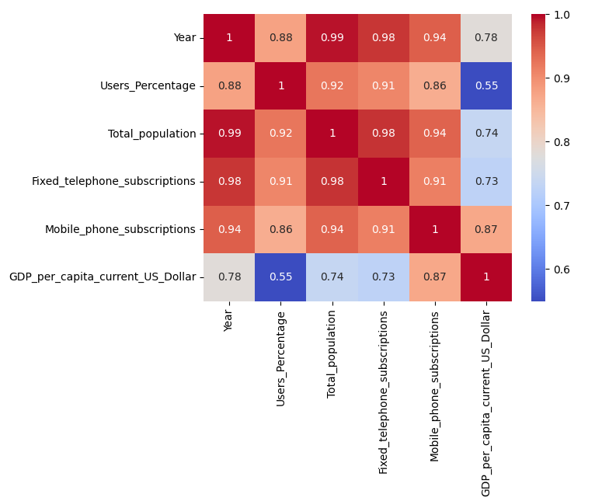
VNR VJIET
Name of the Experiment: _____________
Name of the Laboratory:
Experiment No: ____ Date: _________
Machine Learning Laboratory

indic_df.corr()

sns.heatmap(indic_df.corr(),annot=True,cmap='coolwarm')
plt.show()

23071A1292
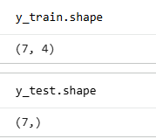
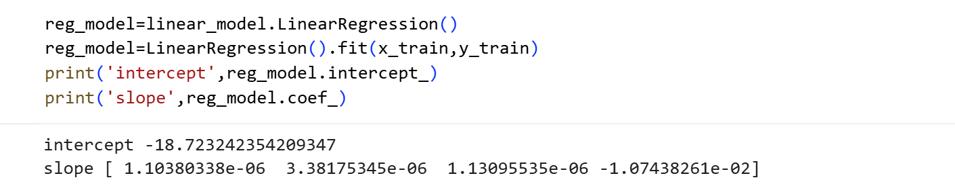
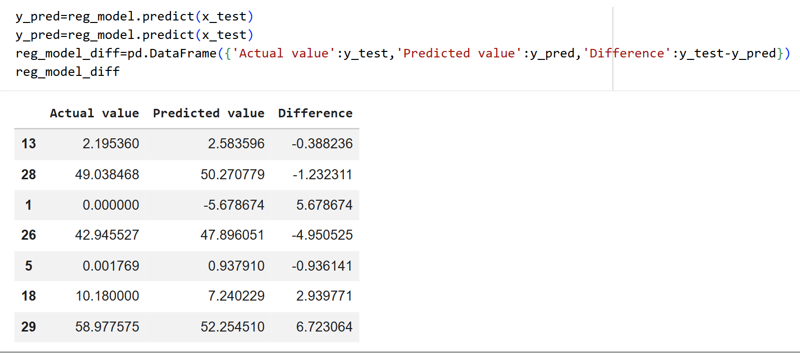

x_train,x_test,y_train,y_test=train_test_split(x,y,test_size=0.2, random_state=100)

23071A1292
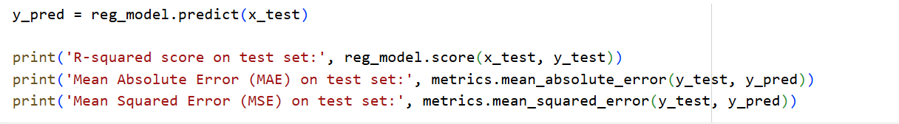
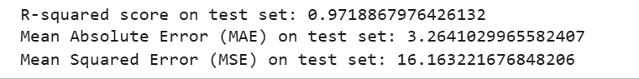
VNR VJIET
Name of the Experiment: _____________
Name of the Laboratory:
Experiment No: ____ Date: _________
Machine Learning Laboratory

23071A1292

23071A1292
VNR VJIET
Name of the Experiment: _____________
Name of the Laboratory:
Experiment No: ____ Date: _________
Machine Learning Laboratory

WEEK 6: Write a program to implement the k-nearest neighbour algorithm
for classifying iris data sets and printing both correct and incorrect
predictions.

from sklearn.datasets import load_iris
from sklearn.neighbors import KNeighborsClassifier
from sklearn.model_selection import train_test_split
import numpy as np

dataset=load_iris()
x_train,x_test,y_train,y_test=train_test_split(dataset["data"],dataset["target"],random_state=50)

kn=KNeighborsClassifier(n_neighbors=1)
kn.fit(x_train,y_train)

kn=KNeighborsClassifier(n_neighbors=2)
kn.fit(x_train,y_train)

kn=KNeighborsClassifier(n_neighbors=5, weights='uniform', algorithm='auto', leaf_size=30, p=3,
metric='minkowski', metric_params=None, n_jobs=None)

kn.fit(x_train,y_train)
for i in range(len(x_test)):
x=x_test[i]
x_new=np.array([x])
prediction=kn.predict(x_new)
print('Target=',y_test[i],dataset["target_names"][y_test[i]],"predicted=",prediction,dataset)
print(kn.score(x_test,y_test))

23071A1292
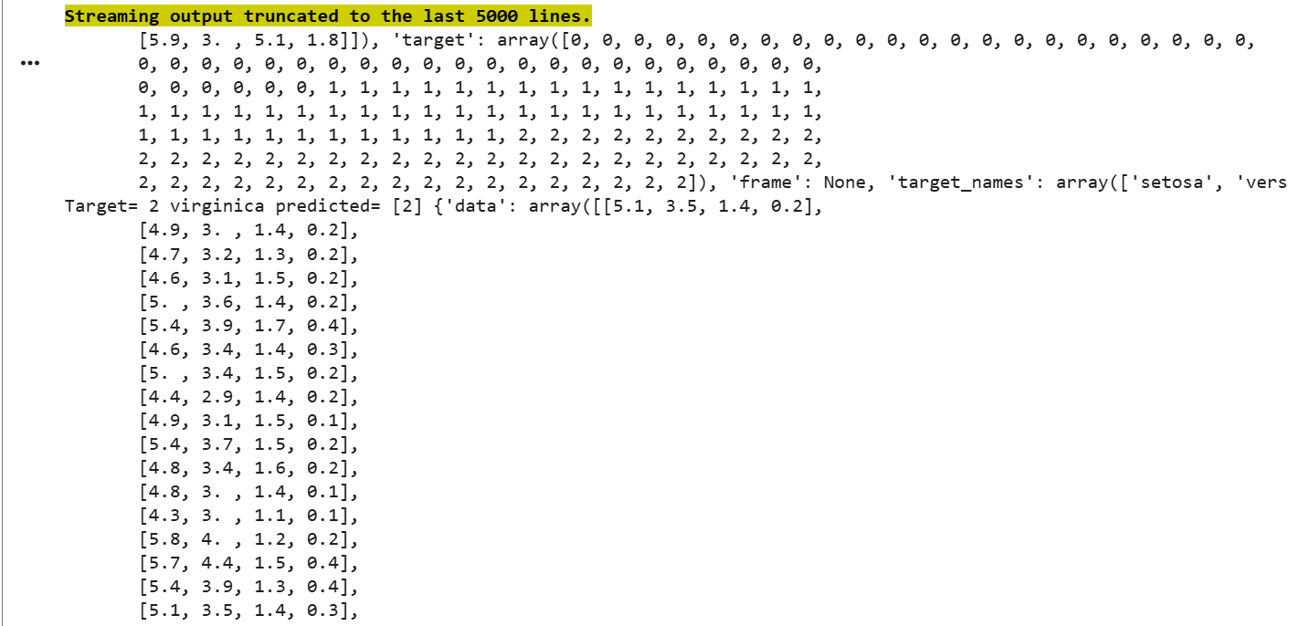
kn=KNeighborsClassifier(n_neighbors=10, weights='uniform', algorithm='ball_tree',
leaf_size=30, p=3, metric='minkowski', metric_params=None, n_jobs=None)

kn.fit(x_train,y_train)
for i in range(len(x_test)):
x=x_test[i]
x_new=np.array([x])
prediction=kn.predict(x_new)
print('Target=',y_test[i],dataset["target_names"][y_test[i]],"predicted=",prediction,datas
et)
print(kn.score(x_test,y_test))

23071A1292
VNR VJIET
Name of the Experiment: _____________
Name of the Laboratory:
Experiment No: ____ Date: _________
Machine Learning Laboratory

WEEK 7: Write a program to implement a decision tree using the ID3
algorithm and apply the knowledge to classify a new sample using the
decision tree.

CODE:
from sklearn.datasets import load_iris
from sklearn.tree import DecisionTreeClassifier,export_graphviz,ExtraTreeClassifier
iris=load_iris()

23071A1292
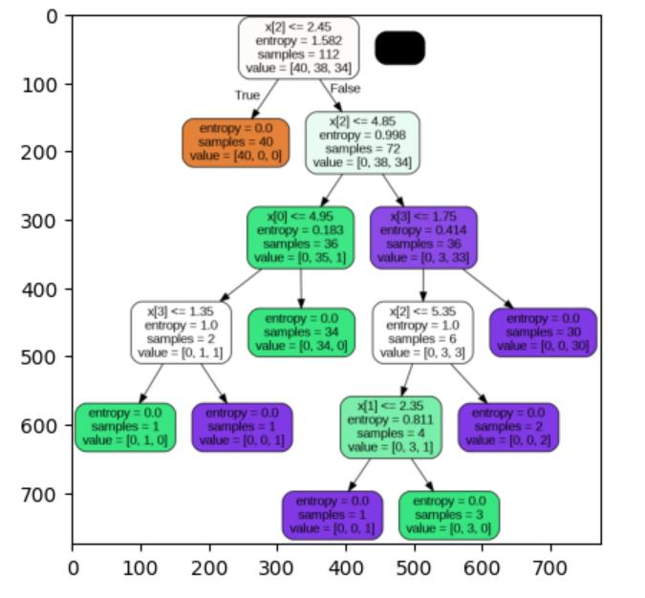
iris.data[:5]
iris.target[:5]

dt=DecisionTreeClassifier(criterion='entropy')
from sklearn.model_selection import train_test_split

trainx,testx,trainy,testy=train_test_split(iris.data,iris.target)
dt.fit(trainx,trainy)

DecisionTreeClassifier(class_weight=None,criterion='entropy',
max_depth=None,max_features=None,max_leaf_nodes=None,min_impurity_decrease=0
.0, min_samples_leaf=1, min_samples_split=2, min_weight_fraction_leaf=0.0,
random_state=None, splitter='best')

export_graphviz(dt,'dt.tree')

from sklearn import tree
import pydotplus

dot_data_string = tree.export_graphviz(dt, filled=True, rounded=True)
graph = pydotplus.graph_from_dot_data(dot_data_string)
graph.write_png("tree.png")
import matplotlib.pyplot as plt
plt.imshow(plt.imread("tree.png"))

23071A1292
VNR VJIET
Name of the Experiment: _____________
Name of the Laboratory:
Experiment No: ____ Date: _________
Machine Learning Laboratory

WEEK 8: To implement different feature selection and extraction techniques

(LDA & PCA) using Python

23071A1292
CODE:

import numpy as np
import pandas as pd
import matplotlib.pyplot as plt
import seaborn as sns
from time import time
from sklearn.datasets import load_wine, load_breast_cancer
from sklearn.preprocessing import StandardScaler

from sklearn.model_selection import train_test_split
from sklearn.linear_model import LogisticRegression
from sklearn.metrics import accuracy_score, recall_score, precision_score
from sklearn.discriminant_analysis import LinearDiscriminantAnalysis
from sklearn.decomposition import PCA

cancer = load_breast_cancer()
data = cancer.data
columns = cancer.feature_names
X = pd.DataFrame(data, columns=columns)
y = pd.Series(cancer.target, name='target')
df = pd.concat([X, y], axis=1)
print(df.sample(10))

scaler = StandardScaler()
X_scaled = scaler.fit_transform(X)

def apply_model(X, y):
X_train, X_test, y_train, y_test = train_test_split(
X, y, random_state=1, test_size=0.3
)
model = LogisticRegression()
model.fit(X_train, y_train)

y_pred = model.predict(X_test)

print("Accuracy:", accuracy_score(y_test, y_pred))

# Re-compute PCA for visualization using breast cancer data
pca = PCA(n_components=2)

23071A1292
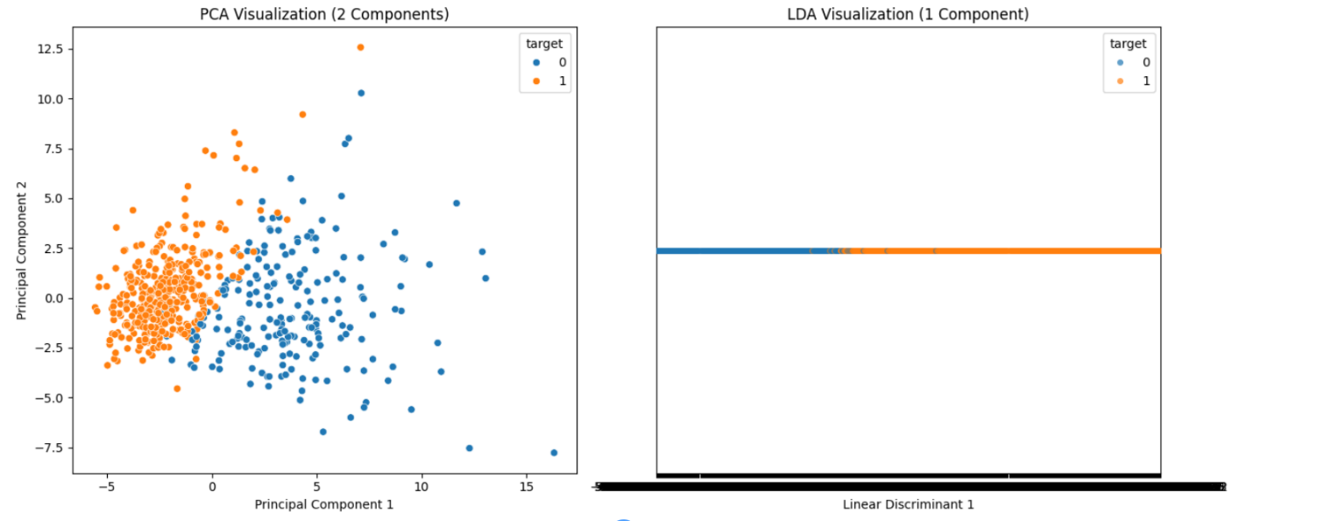
VNR VJIET
Name of the Experiment: _____________
Name of the Laboratory:
Experiment No: ____ Date: _________
Machine Learning Laboratory

X_pca = pca.fit_transform(X_scaled)
df_pca = pd.concat([pd.DataFrame(X_pca, columns=['PC1', 'PC2']), y], axis=1)

# Prepare LDA data for visualization
# X_lda is already a 1-D array from previous step, we'll give it a column name for plotting
df_lda_viz = pd.concat([pd.DataFrame(X_lda, columns=['LD1']), y], axis=1)

# Create the visualization
fig, axes = plt.subplots(1, 2, figsize=(14, 6))

# PCA Visualization
sns.scatterplot(x='PC1', y='PC2', hue='target', data=df_pca, ax=axes[0])
axes[0].set_title('PCA Visualization (2 Components)')
axes[0].set_xlabel('Principal Component 1')
axes[0].set_ylabel('Principal Component 2')

# LDA Visualization (1 Component)
# Using stripplot for 1D data separation by target
sns.stripplot(x='LD1', y=[0]*len(df_lda_viz), hue='target', data=df_lda_viz, ax=axes[1], jitter=0.2,
alpha=0.7)
axes[1].set_title('LDA Visualization (1 Component)')
axes[1].set_xlabel('Linear Discriminant 1')
axes[1].set_ylabel('')
axes[1].set_yticks([]) # Remove y-axis ticks for better 1D visualization

plt.tight_layout()
plt.show()

23071A1292
lda = LinearDiscriminantAnalysis(n_components=1)
lda.fit(X_scaled, y)
X_lda = lda.transform(X_scaled)
df_lda = pd.concat([pd.DataFrame(X_lda), y], axis=1)

print("Original shape:", X_scaled.shape)
print("Reduced shape:", X_lda.shape)

OUTPUT:
Original shape: (569, 30)
Reduced shape: (569, 1)

23071A1292
VNR VJIET
Name of the Experiment: _____________
Name of the Laboratory:
Experiment No: ____ Date: _________
Machine Learning Laboratory

WEEK 9: Write a program to implement the naive Bayesian classifier for a sample
training dataset stored as a CSV file. Compute the accuracy of the classifier, considering
a few test data sets

import kagglehub
path = kagglehub.dataset_download("uciml/pima-indians-diabetes-database")
print("Path to dataset files:", path)

import pandas as pd
df = pd.read_csv(os.path.join(path, 'diabetes.csv'))
print("Dataset loaded successfully. First 5 rows:")
print(df.head())

23071A1292

import os
print(os.listdir(path))
import csv
import random
import math

def loadcsv(filename):
lines=csv.reader(open(filename,"r"))
dataset=list(lines)
# Skip the header row
if len(dataset) > 0:
header = dataset.pop(0)
for i in range(len(dataset)):
dataset[i]=[float (x) for x in dataset[i]]
return dataset

def splitdataset(dataset,splitratio):
trainsize=int(len(dataset)*splitratio)
trainset=[]
copy=list(dataset)
while len(trainset)<trainsize:
index=random.randrange(len(copy))
trainset.append(copy.pop(index))
return [trainset,copy]

def mean (numbers):
return sum(numbers)/float(len(numbers))

def stdev(numbers):
avg=mean (numbers)
variance=sum([pow(x-avg,2)for x in numbers])/float(len(numbers)-1)
return math.sqrt(variance)

def summarize (dataset):
summaries=[(mean(attribute),stdev(attribute))for attribute in zip(*dataset)]
del summaries[-1]
return summaries

def summarizebyclass(dataset):

23071A1292
VNR VJIET
Name of the Experiment: _____________
Name of the Laboratory:
Experiment No: ____ Date: _________
Machine Learning Laboratory

seperated=seperatedbyclass(dataset)
summaries={}
for classvalue,instances in seperated.items():
summaries[classvalue]=summarize(instances) # Corrected 'instance' to 'instances'
return summaries

def calculateProbability (x,mean,stdev):
exponent=math.exp(-(math.pow(x-mean,2)/(2*math.pow(stdev,2))))
return (1/(math.sqrt(2*math.pi)*stdev))*exponent

def calculateClassProbabilities(summaries,inputvector):
probabilities={}
for classvalue,classsumaries in summaries.items():
probabilities[classvalue]=1
for i in range(len(classsumaries)):
mean,stdev=classsumaries[i]
x=inputvector[i]
probabilities[classvalue]*=calculateProbability(x,mean,stdev)
return probabilities

def predict(summaries,inputvector):
probabilities=calculateClassProbabilities(summaries,inputvector)
bestlabel,bestprob=None,-1 # Corrected 'none' to 'None'
for classvalue,prob in probabilities.items(): # Changed 'probabilities' to 'prob' to avoid shadowing
if bestlabel is None or prob > bestprob: # Used 'prob' for comparison
bestprob=prob
bestlabel=classvalue
return bestlabel

def getPedictions(summaries,testset):
predictions=[]
for i in range (len(testset)):
result=predict(summaries,testset[i])
predictions.append(result)
return predictions
def getaccuracy(testset,predictions):
correct=0

23071A1292
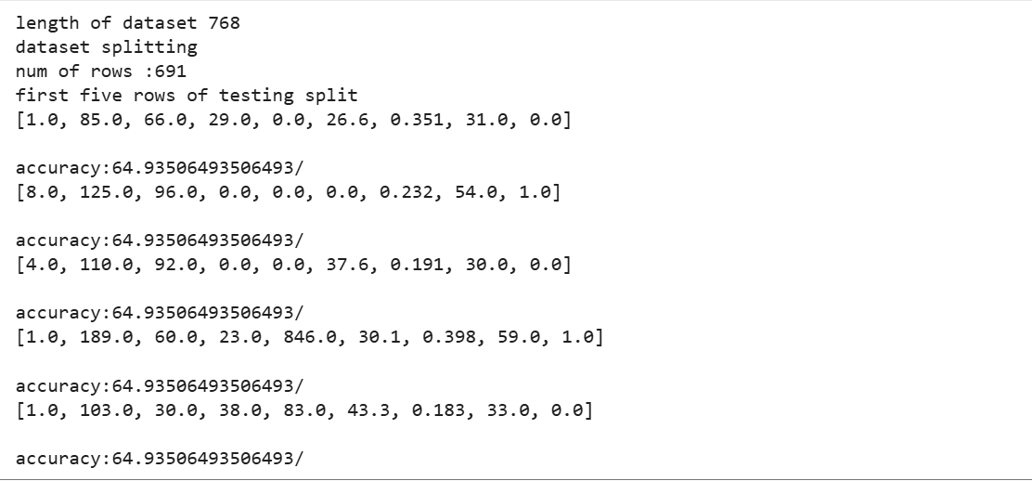
for i in range(len(testset)):
if testset[i][-1]==predictions[i]:
correct+=1
return(correct/float(len(testset)))*100.0

def main():
filename=os.path.join(path, 'diabetes.csv') # Corrected: filename should be the path to the csv file
splitratio=0.9
dataset=loadcsv(filename)
print("length of dataset",len(dataset))
print("dataset splitting")
trainset,testset=splitdataset(dataset,splitratio)
print("num of rows :{0}".format(len(trainset)))
print("first five rows of testing split")
for i in range(0,5):
print(testset[i],"\n")
summaries=summarizebyclass(trainset)
predictions=getPedictions(summaries,testset)
accuracy=getaccuracy(testset,predictions)
print("accuracy:{0}/".format(accuracy))
main()

23071A1292
VNR VJIET
Name of the Experiment: _____________
Name of the Laboratory:
Experiment No: ____ Date: _________
Machine Learning Laboratory

WEEK 10: Write a program to implement SVM for binary classification on a
sample training dataset stored as a CSV file with different kernels.

import matplotlib.pyplot as plt
import pandas as pd
from sklearn.model_selection import train_test_split
df = pd.read_csv(
"https://raw.githubusercontent.com/ampl/mo-
book.ampl.com/refs/heads/dev/datasets/data_banknote_authentication.txt",
header=None,)
df.columns=["variance","skewness","curtosis","entropy","class"]
f=df.name= "Banknotes"
df.head()
df.describe()

df_train, df_test = train_test_split(df, test_size=0.2)

23071A1292
features=["variance","skewness"]
x_train=df_train[features]
y_train=1-2*df_train["class"]
x_test=df_test[features]
y_test=1-2*df_test["class"]

def scatter_labeled_data(x,y,labels=["+1","-1"], colors=["g","r"],**kwargs):
kw={"x":0, "y":1, "kind": "scatter", "alpha":0.4}
kw.update(kwargs)
import warnings
with warnings.catch_warnings():
warnings.filterwarnings("ignore")
kw["ax"] = x[y>0].plot(**kw,c=colors[0], label=labels[0])
x[y<0].plot(**kw, c=colors[1], label=labels[1])
fig, ax= plt.subplots(1,2, figsize=(10,4))
scatter_labeled_data(
x_train,
y_train,
labels=["genuine", "counterfeit"],
ax=ax[0],
title="Training Set",
)
scatter_labeled_data(
x_test,
y_test,
labels=["genuine", "counterfeit"],
ax=ax[1],
title= "Test Set",
)

import pandas as pd
import numpy as np
class linearSVM:
def __init__(self,w,b):
self.w=pd.Series(w)
self.b=float(b)
def __call__(self,X):
return np.sign(X.dot(self.w)+self.b)
def __repr__(self):
return f"linearSVM(w={self.w.to_dict()}, b={self.b})"

w=pd.Series({"variance":1,"skewness":0})
b=0
svm=linearSVM(w,b)

23071A1292
VNR VJIET
Name of the Experiment: _____________
Name of the Laboratory:
Experiment No: ____ Date: _________
Machine Learning Laboratory

print(svm)
y_pred=svm(x_test)
accuracy=sum(y_pred==y_test)/len(y_test)
print(f"Accuracy;{100*accuracy:0.1f}%")

def scatter_comparison(X,y,y_pred):
xmin,ymin=X.min()
xmax,ymax=X.max()
xlim=[xmin-0.5*(xmax-xmin),xmax+0.5*(xmax-xmin)]
ylim=[ymin-0.5*(ymax-ymin),ymax+0.5*(ymax-ymin)]
labels=["genuine","counterefiet"]
fig,ax= plt.subplots(1,2, figsize=(10,4))
scatter_labeled_data(
X,y, labels,["g","r"],
ax=ax[0],
xlim=xlim,
ylim=ylim,
title="actual")
scatter_labeled_data(
X[y<0],
y_pred[y<0],
["false posiive","true negative"],
["c","m"],
xlim=xlim,
ylim=ylim,
ax=ax[1],
title="actual negatives")
scatter_labeled_data(
X[y>0],
y_pred[y>0],
["true posiive","false negative"],
["c","m"],
xlim=xlim,
ylim=ylim,
ax=ax[1],
title="actual positives")

scatter_comparison(x_test,y_test,y_pred)

scatter_comparison(x_test,y_test,y_pred)

23071A1292
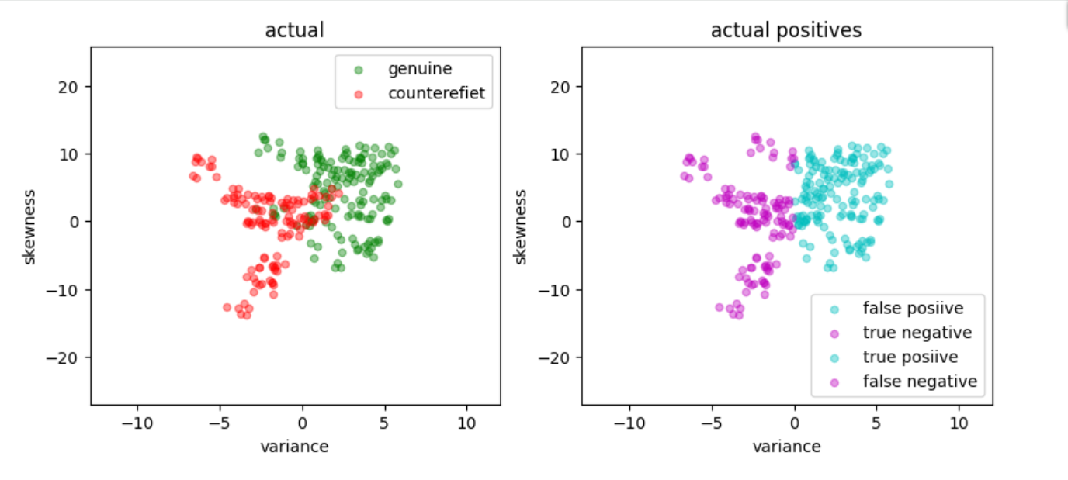

Output:

Case-1:

from sklearn import svm
svm_model = svm.SVC(C=2.0, kernel="linear")
svm_model.fit(x_train,y_train)
ypred= svm_model.predict(x_test)
accuracy=np.mean(ypred==y_test)
print(f"Accuracy: {100*accuracy:0.1f}%")
output:
Accuracy: 86.2%

Case-2:
from sklearn import svm
svm_model = svm.SVC(C=2.0, kernel="rbf")
svm_model.fit(x_train,y_train)
ypred= svm_model.predict(x_test)
accuracy=np.mean(ypred==y_test)
print(f"Accuracy: {100*accuracy:0.1f}%")
output:
Accuracy: 89.8%

Case-3:
from sklearn import svm
svm_model = svm.SVC(C=2.0, kernel="sigmoid")

23071A1292
VNR VJIET
Name of the Experiment: _____________
Name of the Laboratory:
Experiment No: ____ Date: _________
Machine Learning Laboratory

svm_model.fit(x_train,y_train)
ypred= svm_model.predict(x_test)
accuracy=np.mean(ypred==y_test)
print(f"Accuracy: {100*accuracy:0.1f}%")
Output: Accuracy: 61.5%

Case-4:
from sklearn import svm
svm_model = svm.SVC(C=2.0, kernel="poly")
svm_model.fit(x_train,y_train)
ypred= svm_model.predict(x_test)
accuracy=np.mean(ypred==y_test)
print(f"Accuracy: {100*accuracy:0.1f}%")
Output: Accuracy: 87.3%

def decision_boundary_plot(X,y,model):
x_min,x_max=X.iloc[:,0].min()-0.5,X.iloc[:,0].max()+0.5
y_min,y_max=X.iloc[:,1].min()-0.5,X.iloc[:,1].max()+0.5
xx,yy=np.meshgrid(np.arange(x_min,x_max,0.02),np.arange(y_min,y_max,0.02))
x_in=np.c_[xx.ravel(),yy.ravel()]
y_pred=model.predict(x_in)
y_pred=y_pred.reshape(xx.shape)
plt.contourf(xx,yy,y_pred, alpha=.5,cmap='winter')
plt.scatter(X.iloc[:,0],X.iloc[:,1],c=y,cmap='spring',edgecolor='b')
plt.show()
decision_boundary_plot(x_test,y_test,svc)

kernels=["linear","sigmoid","poly"]
for i, kernel_name in enumerate(kernels):
svc = svm.SVC(C=2.0, kernel=kernel_name)
svc.fit(x_train, y_train)
decision_boundary_plot(x_test, y_test, svc)
plt.show()

23071A1292
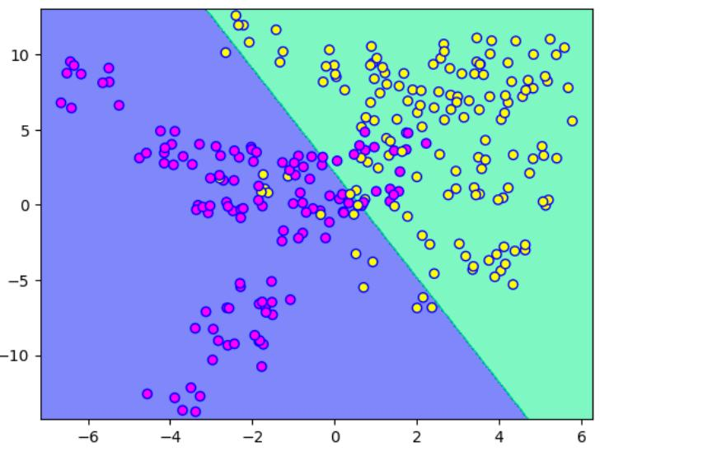
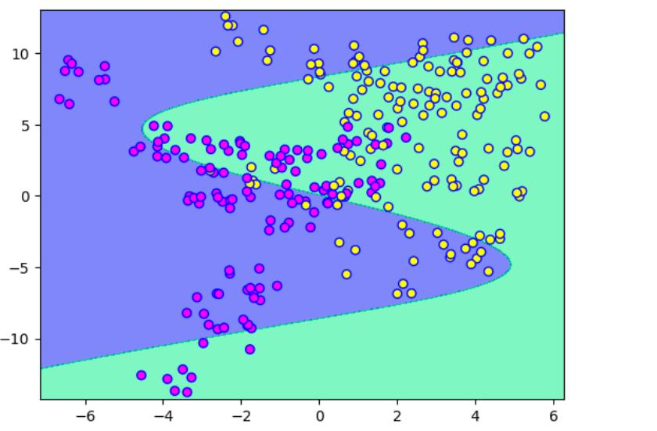
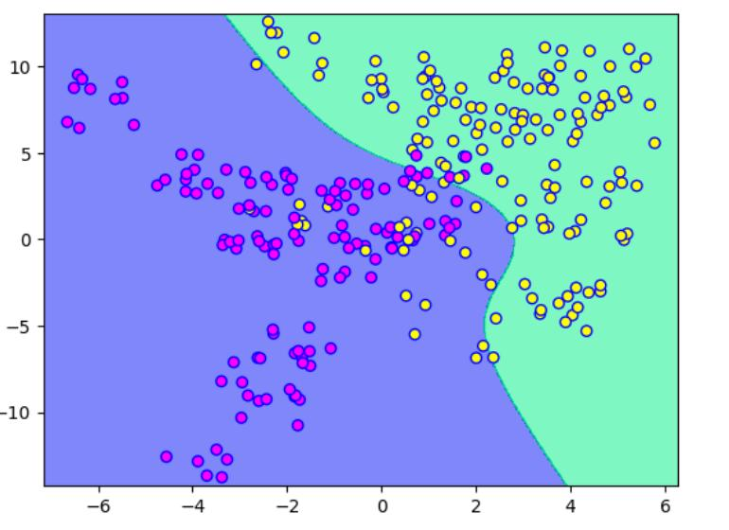
Outputs:

23071A1292

